INSERT COMPANY LOGO

PHOTO

FIRST NAME LAST NAME
Company Name
Facility Address Line 1
Facility City, State Zip
United States
Designated Critical Infrastructure Worker as a Critical Infrastructure Partner in the Food Sector by
Public Safety Canada

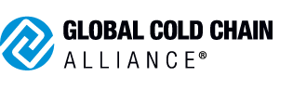

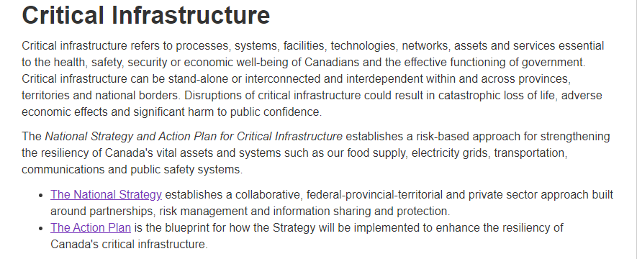
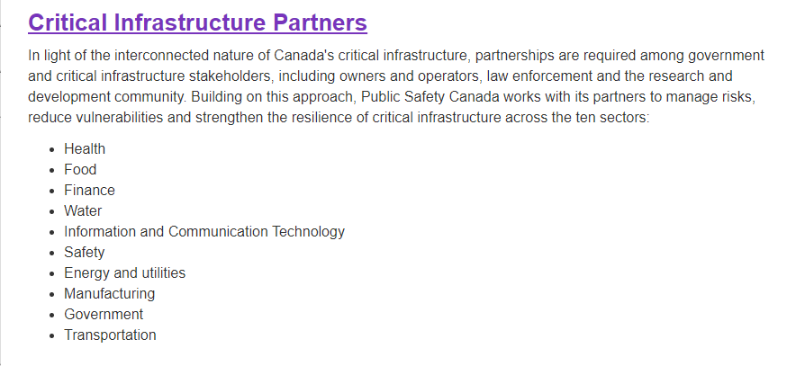
Source: https://www.publicsafety.gc.ca/cnt/ntnl-scrt/crtcl-nfrstrctr/index-en.aspx

