Click or tap to enter a date

Dear Enter Distributor Name,

We commend you and thank you for your efforts in helping fight the spread of the COVID-19 virus. We understand that your company has been asked to prioritize orders of personal protective equipment for the food and agriculture sector. Our association, the Global Cold Chain Alliance, represents all major industries engaged in temperature-controlled logistics who are working to get refrigerated and frozen food products to grocery store shelves.

One of our member companies, Enter Your Company Here, is a critical link in the cold chain food supply and has been deemed an “essential business and service” under the Presidential Policy Directive 21 (PPD-21). Designated as such in a memo from the U.S. Department of Homeland Security (relevant pages attached), they are recognized as essential infrastructure keeping the country safe and fed during this pandemic and their employees will need to continue working. We want to keep them safe and keep the country’s food safe and on the shelves.

We ask that if you have the production capacity to sell to them, please do so to help them safely deliver food to the American people. We thank you again for your efforts in these unprecedented times.

Sincerely,
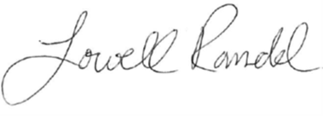

Lowell Randel
Vice President of Government and Legal Affairs
Global Cold Chain Alliance

